Antibiotics. Cephalosporins.
Cephalosporins are another important group of β-lactam antibiotics. Cephalosporin C was first discovered in 1945. It was obtained from the culture of Cephalosporium acremonium in 1950. G. Rodzu. Cefamycin was later isolated from mushroom culture in 1971. и цефабазин в 1984 г. However, although these compounds are active against gram(+) and gram(-) bacteria, due to their low activity, they are considered unsuitable compounds from a clinical point of view. However, these compounds are used in the synthesis of semisynthetic derivatives of cephalosporins.
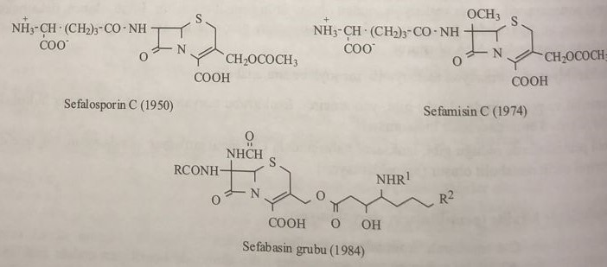
Structure and nomenclature of cephalosporins.
Cephalosporins preserve the basic structure of bicyclic 5-thia-1-azabicyclo[4.2.0]octane formed by condensation of β-lactam and 1,3-thiazine rings. In this structure, a double bond between the second and third states is preserved, and, unlike penicillins, the sepham ring has one unsaturated group. Therefore, it is called 5-thia-1-azabicyclo[4.2.0]octan-2-ene. In general, if the saturated ring systems of cephalosporin are replaced by isosteres of the sulfur atom in the fifth position, derivatives of carbazepam, tsepama and oxozepam are formed.
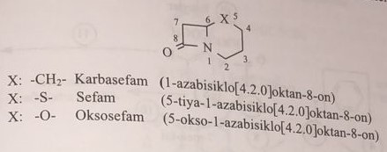
If there is a double bond between the third and second states, the compounds are called carbazephem, cephem, and oxozephem. In natural cephalosporins with open formulas above, the main functional group is: a carboxyl group in the second position, an acetoxymethyl group in the third position, an acylamino group in the seventh position, and an oxo group in the eighth position. Thus, the general basic structure is 7-amino-3-acetoxymethyl-8-oxo-5-thia-1-azabicyclo[4.2.0]oct-2-ene-2-carboxylic acid, synonym (7-aminocephalosporanic acid) also is called
7-amino-3-deacetoxycephalosporinic acid (7-АДСТ) is formed by replacing the 3-acetoxymethyl group with a methyl group. Simultaneous bromination of the methyl group attached to the third position in 7-ADST gives 7-amino-3-bromomethylcephalosporinic acid (7-ABST).
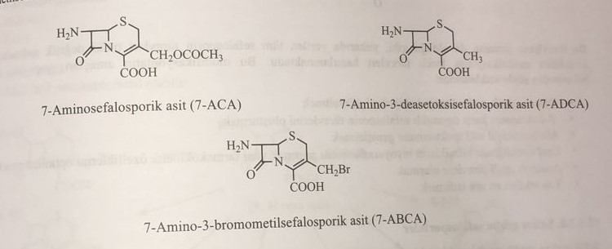
Natural cephalosporins isolated from the fermentation medium could not find clinical use in antibacterial purposes. Since, as in the biosynthesis of penicillins, the acid that will form the side chain is added to the environment as a precursor and does not create conditions for the production of biosynthetic cephalosporins that retain acyl groups such as phenylacetic acid or phenoxymethylacetic acid instead of α-aminoadipoyl side chain on the seventh position. Therefore, all cephalosporins used in the clinic are obtained with the help of 7-ASDT, 7-ADST or 7-ABST. The basic structure for molecular modifications carried out by chemical derivatization of cephalosporins is 7-AST.
General scheme of derivatization and structure-activity relationship of cephalosporins.
All of the above-mentioned molecular modifications of cephalosporins are schematically based on the structure of cefam.
The stability of the molecule conjugated with 7α-acylamino in the seventh position is high. Oral use of this group of derivatives is possible for him. Taking into account high antibacterial activity and especially resistance to β-lactamases, it is shown that inclusion in the molecular structure of the 2-aminothiazol group and its derivatives, which are included in the third group of the oximetric group of cephalosporins, is very effective. The methoxy group attached to the molecule in the seventh position ensures the formation of a new asymmetric ring in the main structure, turning the β-lactam structure into a molecularly stable form against β-lactamase. At the same time, the activity against anaerobic bacteria increases. However, one of the disadvantages is that it increases the risk of bleeding in the patient. Addition of acetoxy group in the third position increases the pharmacokinetic stability and half-life of the antibiotic.
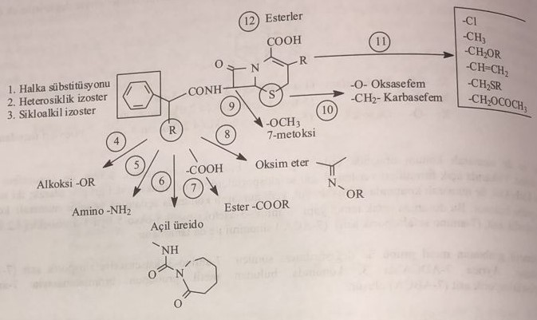As in this derivatization scheme, all the above-mentioned cephalosporin derivatives originate from 12 different points with different molecular modifications. The purpose of these modifications is explained from the structural and operational point of view as follows:
1) Mainly for strengthening the antibacterial effect.
2) for obtaining β-lactamase-resistant cephalosporins.
3) Expand the spectrum of antibacterial action.
4) Increase in bioavailability of orally used compounds and optimization of their pharmacokinetic properties.
5) Obtaining anaerobically effective derivatives.
6) reduce side effects.
Cephalosporin groups of cephemus
Since cephalosporin antibiotics cannot be obtained biosynthetically, they are produced synthetically. 7-AST functional groups are included in the reaction. The main functional groups retained by 7-AST are the amine in the seventh position, the acetoxymethyl group in the third position, and the carboxyl group in the second position. The three main functional groups in this structure play a key role in the chemical derivatization of the molecule. These reactions are explained in order of importance as follows:
а) Substitution of the amino group in the seventh position
The reactions carried out on this group proceed in 3 stages, as shown in the diagram below.
1) Acylation by organic carboxylic acid
2) Alkylation by alkyl halide
3) Formation of Schiff base as a result of condensation with aromatic or aliphatic aldehyde
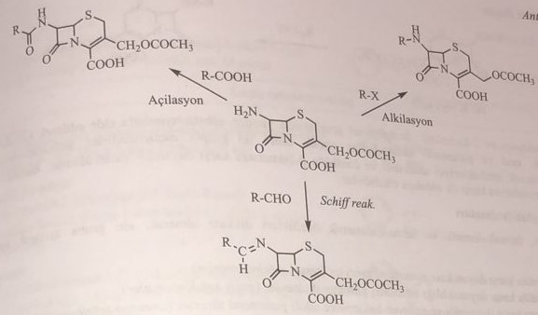
b) Replacement of the acetoxymethyl group in the third position
1) Acetoxymethyl group can be replaced by many radicals. In this situation, these groups are successively united.
1) Methyl
2) Bromomethyl
3) Hydroxymethyl
4) Carbamoyloxymethyl
5) hydroxy
6) Chlorine
7) Methylene
8) Aminomethyl
9) Alkyl, aryl, mercaptomethyl
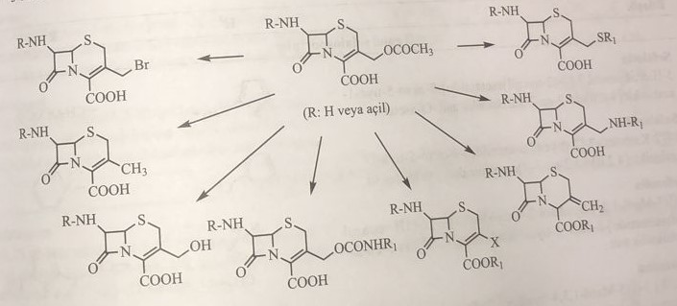
c) Substitution of the carboxyl group in the second position
Ester derivatives are obtained from the esterification of the carboxyl group in this position with various alcohols, and thus the ionic structure is brought to a non-polar state. With these properties, the biological absorption properties of the molecule increase and its oral use becomes easier.
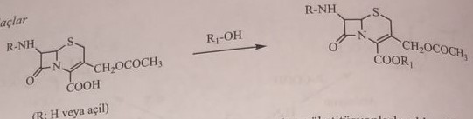
Cephalosporins obtained by substitution in 7-amino, 3-acetoxy and 2-carboxy functional groups are divided into two groups: oral and parenteral. Cephalosporins are broad-spectrum compounds with high antibacterial activity and especially resistant to β-lactamase. Some are quite active against anaerobic bacteria.
1) Parenteral derivatives resistant to β-lactamase (Main cephalosporins)
2) Derivatives with increased resistance to β-lactamase (Transitional cephalosporins)
3) derivatives resistant to β-lactamase and active against anaerobic bacteria (anaerobic cephalosporins)
4) β-lactamase-resistant, broad-spectrum derivatives (broad-spectrum cephalosporins)
5) oral derivatives resistant to β-lactamase (old oral cephalosporins)
6) oral derivatives resistant to β-lactamase (new oral cephalosporins)
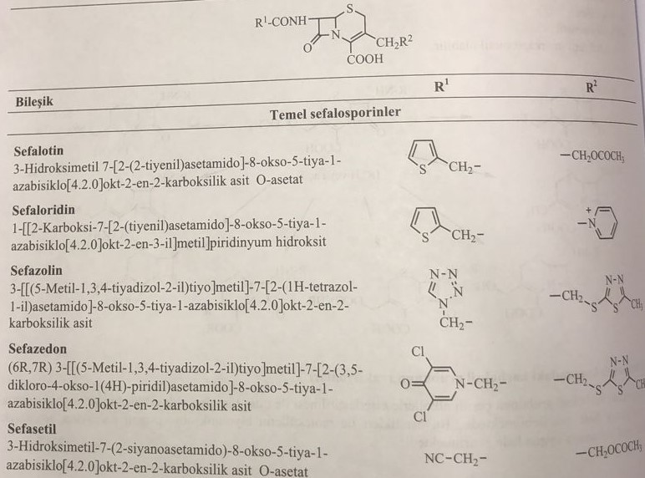
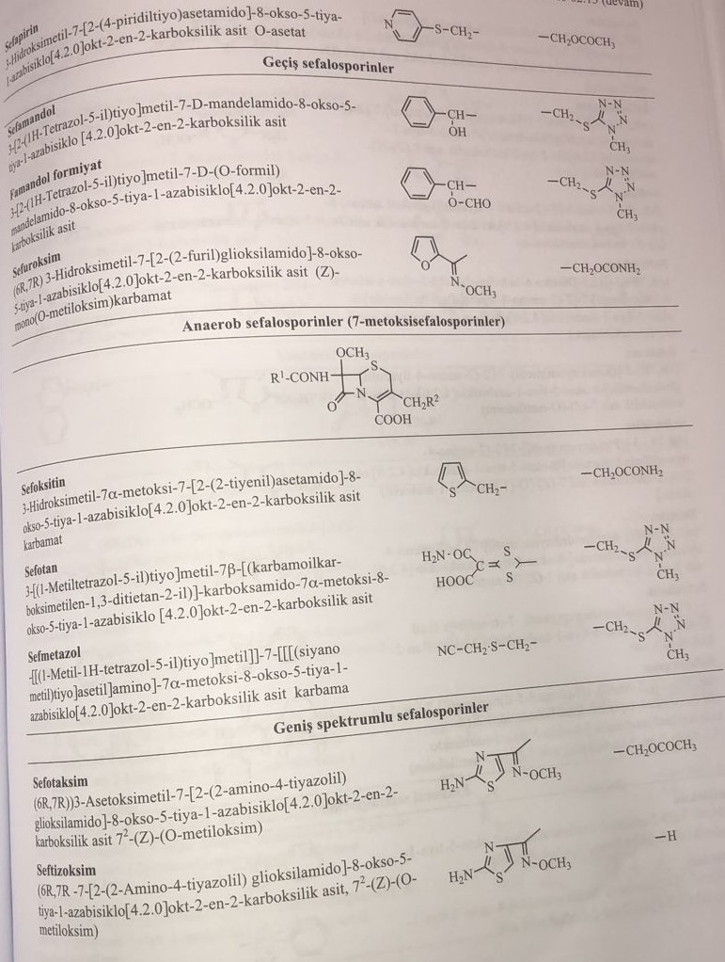
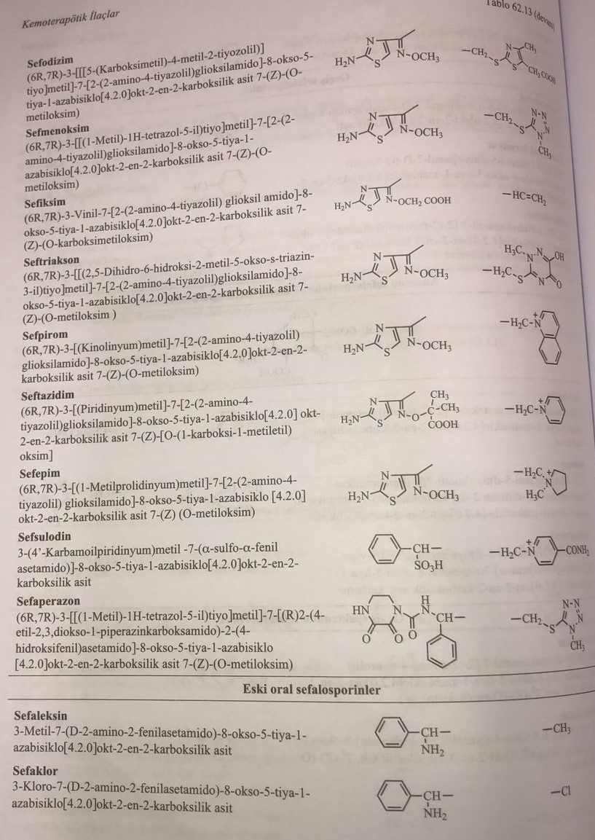
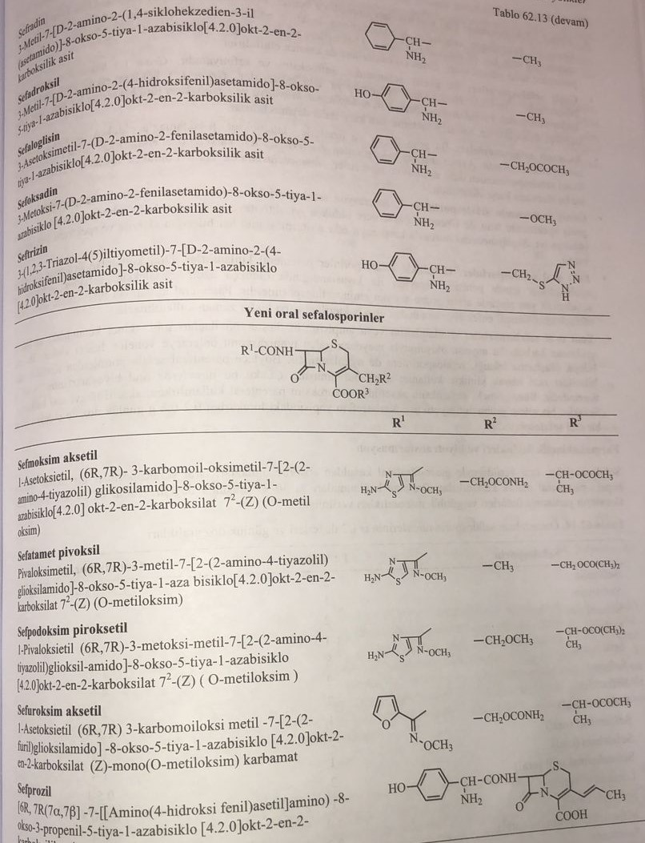

Biological properties
The main cephalosporins: the spectrum of action is similar to ampicillin. It is effective against penicillin-expressing staphylococci, inactivated by β-lactamase, secreted by Gram(-) bacteria. The first compound, cephalothin, is metabolized by deacetylation and has a half-life of 40 minutes. Active against gram (+) bacteria. Other compounds have a higher potential of action against gram(+) bacteria and are partially active against gram(-) bacteria.
Transitional cephalosporins: The first representatives are cefamandol, cefmoxin and cefotiam. Active compounds against gram(-) bacteria. They especially affect Hemophilus influenzae. Effective against gram(+) cocci, has a wider spectrum of action. Pseudomonas, enterococci, mycoplasmas, chlamydia and species of mycobacteria are quite resistant to this derivative. However, the drug is resistant to β-lactamase.
Anaerobic cephalosporins. This group of drugs, especially latamoxef, has high resistance to beta-lactamase. At the same time, they have special activity against bacteria and bacteria. Compared to the main cephalosporins, they are less effective on gram (+) bacteria. They have a very weak effect against hemophiliacs. Pseudomonas is resistant to this group.
Cephalosporins have a wide spectrum of action. Also called cephalosporins of the third generation, these compounds are specific against both broad-spectrum bacteria and gram(-) bacteria. Ceftazidime has a strong effect on Pseudomonas aeruginosa and a weak effect on staphylococcus.
Old oral cephalosporins: cephalosporins are mainly preparations for parenteral administration. Among β-lactam antibiotics, examples of oral use are less in cephalosporins than in penicillins. Cephalexin, cefaclor, cefradin and cefadroxil are aminocephalosporins that retain an amino group in the side chain. They have a weaker effect than parenterally applied derivatives. They are not the drugs of choice against bacteria that cause fatal infections.
New oral cephalosporins: to prevent the ionization of the carboxyl group in the second position with the formation of a carboxylate anion, for example, diester prodrugs sultamicillin or ampicillin, the method of improving diester prodrugs was applied to cephalosporins. Thus, some compounds derived from parenteral cephalosporins are suitable for oral administration. Since the oral bioabsorption of these derivatives is more than 60%. An example of such compounds is cefuroxime axetil. While cefuroxime is used parenterally, the derivative axetil is used orally. Cefaclor is an antibiotic of the cefemov group. Loracarbef in the composition of carbazephem is a very effective antibiotic, used in a daily dose of 0.2-0.8 g.
Pharmacokinetic properties and biotransformation
Cephalosporins are not absorbed from the gastrointestinal tract when taken orally. Except for oral cephalosporins, other groups of cephalosporins are used practically parenterally. Protein binding fluctuates between 30-95%. In the table below, the half-life periods of some derivatives are listed.
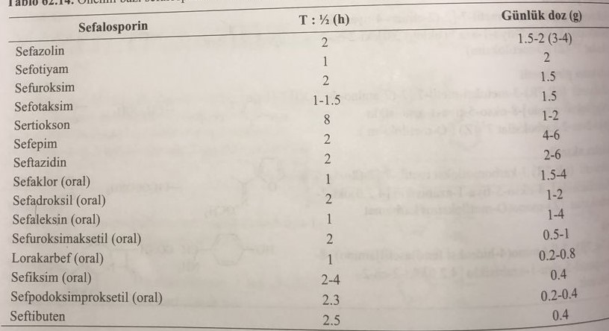
In their biotransformation, the first metabolite is formed by deacetylation of the third state. Active metabolites are ineffective or poorly effective compared to cephalosporins. Elimination of cephalosporins from the body occurs in unchanged form or in the form of metabolites through the kidneys. For this, some derivatives are used in the treatment of urinary infections. Some of them enter the intestines directly or by the gastro-hepatic route and cause a violation of the intestinal microflora. Thus, gastrointestinal symptoms such as diarrhea and nausea occur. Elimination of cephalosporins from the body is somewhat delayed in patients with renal insufficiency. Therefore, the use of cephalosporins in these patients is limited.
Parenteral drugs are used for respiratory tract infections and infections resulting from trauma. These drugs are prescribed before and after interventions, especially in open operations. Anaerobic effective derivatives are used as therapeutic and prophylactic agents, especially in gynecology, in wounds. As in the case of penicillins, allergic side effects are also observed when using cephalosporins. Cross-allergy with penicillins was observed in many derivatives of cephalosporins. Oral cephalosporins are used for respiratory, urinary and skin infections. It is widely used in clinical practice as a highly effective drug for infections caused by staphylococci, Escherichia coli and Klepsiella.
MPK values, reflecting the activity of some derived cephalosporins, are shown in the table below.
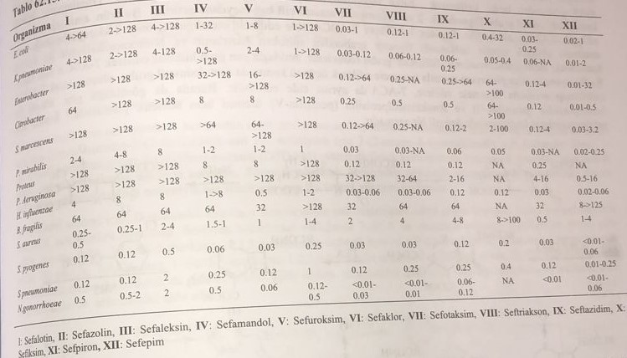
Cephalosporins are less toxic than penicillins. It has been established that cephaloridine, one of the first derivatives, has a nephrotoxic effect. However, these side effects are not observed or are observed very rarely in derivatives that have recently been introduced into medical practice. The use of these drugs is limited to patients with renal insufficiency. Unlike penicillins, anaphylactic shock is rarely observed. In the third case, cephalosporins containing the thiotetrazol group cause blood clotting disorders in the blood system, as they affect the metabolism of vitamin K. Therefore, as a protection, the patient is prescribed a certain dose of vitamin K. Consumption together with alcohol is not allowed. In particular, cephalosporins containing the N-methylthiotetrazol group cause delirium syndrome, which is observed in the drug disulfiram (teturam), which is used in the treatment of alcoholics.
Reception of cephalosporins
7-AST is the main compound used in the synthesis of cephalosporins. 7-AST is obtained synthetically by removing the adipoyl group, as well as by splitting cephalosporin-C with the enzyme amidase. By adding ammonia to the fermentation medium with amidase, the adipoyl group is removed. In the synthetic method, the pyran ring is obtained by the interaction of cephalosporin C with N-nitrosyl chloride in the medium of formic acid. Cephalosporin C, which turns into a derivative of 2-pyranimine-5-carboxylic acid, hydrolyzes with water to produce 7-AST.
Cephalosporins are less toxic than penicillins. It has been established that cephaloridine, one of the first derivatives, has a nephrotoxic effect. However, these side effects are not observed or are observed very rarely in derivatives that have recently been introduced into medical practice. The use of these drugs is limited to patients with renal insufficiency. Unlike penicillins, anaphylactic shock is rarely observed. In the third case, cephalosporins containing the thiotetrazol group cause blood clotting disorders in the blood system, as they affect the metabolism of vitamin K. Therefore, as a protection, the patient is prescribed a certain dose of vitamin K. Consumption together with alcohol is not allowed. In particular, cephalosporins containing the N-methylthiotetrazol group cause delirium syndrome, which is observed in the drug disulfiram (teturam), which is used in the treatment of alcoholics.
Reception of cephalosporins
7-AST is the main compound used in the synthesis of cephalosporins. 7-AST is obtained synthetically by removing the adipoyl group, as well as by splitting cephalosporin-C with the enzyme amidase. By adding ammonia to the fermentation medium with amidase, the adipoyl group is removed. In the synthetic method, the pyran ring is obtained by the interaction of cephalosporin C with N-nitrosyl chloride in the medium of formic acid. Cephalosporin C, which turns into a derivative of 2-pyranimine-5-carboxylic acid, hydrolyzes with water to produce 7-AST.
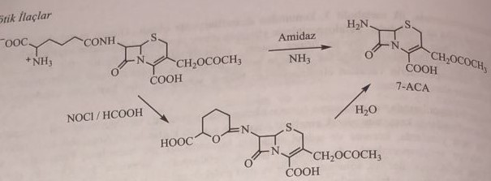
7-AST, 7-АДСТ, 7-АБСТ, penicillin G or penicillin V are mainly used as starting materials in industry. Penicillin V is mainly used in industry because it is more stable. At the first stage, the carboxyl group in the molecule is protected by esterification with 4-nitrobenzyl alcohol. Then, the thioether structure on the thiazole ring is converted into sulfoxide by sodium periodate. This intermediate compound is heated in acetic anhydride for the growth of one of the two methyl groups in the third position of the thiazole ring with the formation of a thiazine ring. In the case of triethylamine, the acetyl group in the third position is removed, forming a double bond between the second and third positions. This product is fermented with amidase to produce 7-ADST. 7-АСТ and 7-АБСТ can be obtained from it. To do this, the thioether group of the thiazine ring is converted into sulfoxide by interaction with 3-chlorperbenzoic acid, and the methyl group in the third position is brominated with N-bromosuccinimide. The sulfoxide group is restored, and the side group is hydrolyzed by amidase with the formation of 7-ABST. Before the restoration of potassium acetate in the third position, an acetoxymethyl group is formed. Then 7-ADST is restored and fermented with amidase to obtain 7-AST. As you can see here, the industrial production of benzylpenicillin and phenoxymethylpenicillin is a very important process for obtaining both penicillins and cephalosporins.
7-AST, 7-АДСТ, 7-АБСТ, penicillin G or penicillin V are mainly used as starting materials in industry. Penicillin V is mainly used in industry because it is more stable. At the first stage, the carboxyl group in the molecule is protected by esterification with 4-nitrobenzyl alcohol. Then, the thioether structure on the thiazole ring is converted into sulfoxide by sodium periodate. This intermediate compound is heated in acetic anhydride for the growth of one of the two methyl groups in the third position of the thiazole ring with the formation of a thiazine ring. In the case of triethylamine, the acetyl group in the third position is removed, forming a double bond between the second and third positions. This product is fermented with amidase to produce 7-ADST. 7-АСТ and 7-АБСТ can be obtained from it. To do this, the thioether group of the thiazine ring is converted into sulfoxide by interaction with 3-chlorperbenzoic acid, and the methyl group in the third position is brominated with N-bromosuccinimide. The sulfoxide group is restored, and the side group is hydrolyzed by amidase with the formation of 7-ABST. Before the restoration of potassium acetate in the third position, an acetoxymethyl group is formed. Then 7-ADST is restored and fermented with amidase to obtain 7-AST. As you can see here, the industrial production of benzylpenicillin and phenoxymethylpenicillin is a very important process for obtaining both penicillins and cephalosporins.
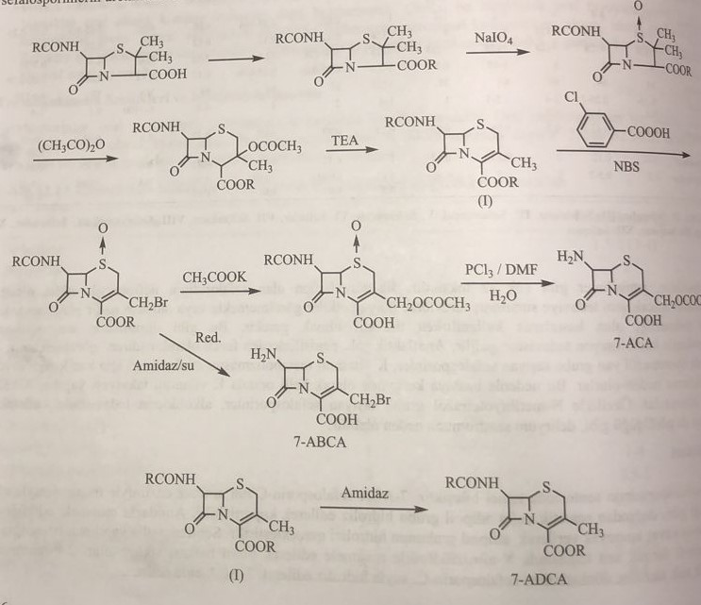
The main cephalosporins
For the synthesis of these compounds, 7-acylamino derivatives are first obtained by reacting 7-AST with various carboxychlorides in a weakly basic medium, such as sodium bicarbonate or tributylamine. Then, when interacting with nucleophiles such as pyridine and 5-methyl-2-mercaptothiadiazole, the acetoxy group in the third position undergoes a substitution reaction.
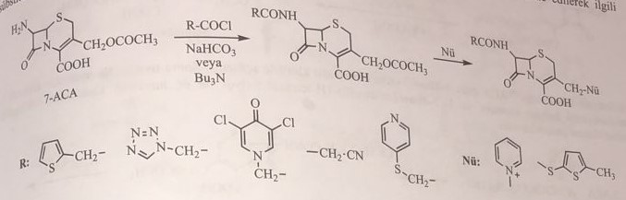
Transient cephalosporins
In the synthesis of this group of compounds, mandelic acid is used for cefamandol, syn-2-methoxyimino-2-(2-furyl)acetic acid for cefuroxime, and 2-(2-amino-4-thiazolyl)acetic acid for cefotiam. when acylating the amino group in the seventh position. First, the carboxyl group in 7-AST is protected by esterification with diphenyldiazomethane, and then the amino group in the seventh position is acylated with the corresponding carboxylic acids. Then, in the third case, the replacement is made.
For the synthesis of cefamandol, D-mandelic acid is first esterified with formic acid and the hydroxyl group is protected. Then prepare mandeline chloride with thionyl chloride. 7-acylaminoproizvodnoe is obtained by interaction with 7-AST in the medium of sodium bicarbonate. This intermediate compound undergoes a tertiary substitution reaction with 1-methyl-5-mercapto-1,2,3,4-tetrazole to obtain cefamandol formate. The resulting cefamandol formate is heated with sodium bicarbonate, while the ether bond is broken, and the result is cefamandol.
Cefuroxim is synthesized from cephalothin. First, the carboxyl group is esterified with diphenyldiazomethane. The third state is first diacetylated, and the aminocarbonyloxymethyl group is obtained from chlorosulfonyl isocyanate. Then thiophene is hydrolyzed by acetic acid. (Z)-2-Methoxyimino-2-(2-furyl)acetic acid is acylated in the presence of dicyclohexylcarbodiimide. Benzhydryl group is removed by trifluoroacetic acid.
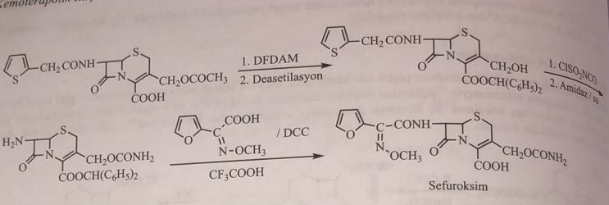
When synthesizing cefotiaam, 7-AST is first acylated with 4-chloro-3-oxyfatty acid chloride. Then, by reacting with thiosidic acid, they get a 2-aminothiazole cycle and carry out a nucleophilic substitution reaction in the third position with 1-(2-dimethylaminoethyl)-1-H-tetrazol-5-thiol.
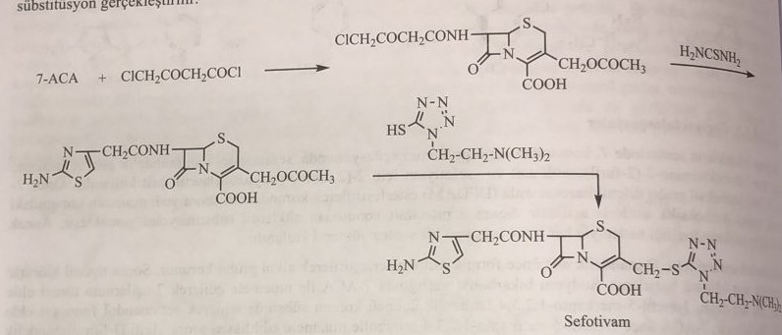
Anaerobic cephalosporins
Cefoksidin, cefotetan and cefmetazol are natural derivatives of cefomycin C, which retain the second methoxy group in the seventh position in addition to the 7-acylamino group.
For the synthesis of cefoxide, the amino group located in the adipoyl side chain of cefamycin C is first acylated with trichlorethylcarbonate. Two carboxyl groups in the molecule are esterified and protected by interaction with diphenyldiazomethane. Then, with the help of carbonic acid chlorides, such as 2-thiophenylacetic acid chloride, used in the synthesis of cefoxidin, the amide group in the seventh position turns into an imide group. Excess adipic acid is removed from the molecule by reduction with a zinc/acetic acid mixture. The drug is obtained by hydrolysis of the ether in the second position with trifluoroacetic acid.
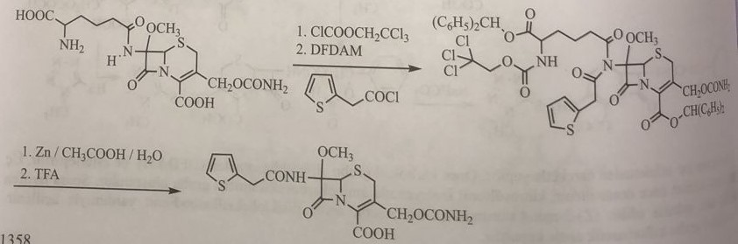
7-amino-3-(1-methyl-1H-tetrazol-5-thioxy)methylcephalosporin acid is used for the synthesis of cefmetazol and cefotetan. First, a methoxy group is attached to the seventh position. For this, the Schiff base of the amine group in the seventh position is prepared by reacting with 3,5-tert-butyl-4-hydroxybenzaldehyde, then it is oxidized with lead dioxide and ketone conjugation is carried out with the phenol group in the para position and methanol is combined in the seventh position. After the addition of the methoxy group to the seventh position, the azomethine bond is broken with Girard T (acetohydrazide+trimethylammonium chloride). Thus, 7-amino-7-methoxy-3-(1-methyl-1H-tetrazol-5-thioxy)methylcephalosporin acid is obtained. The synthesis of the drug is completed by acylating the amino group in the seventh position with appropriate carbonic acid chlorides.
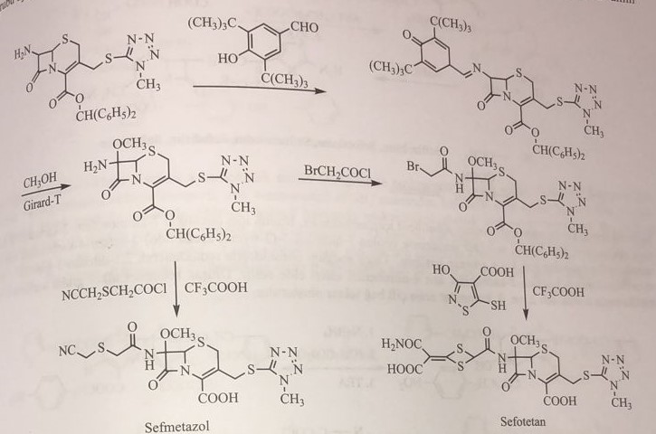
Cephalosporins have a wide spectrum of action
This group of compounds is also called cephalosporins of the third generation. In addition to cefaperazone, in such derivatives as cefotaxime, ceftrioxime, cefmenoxime, cefixime, ceftriaxone, ceftazidime and cefepime, the amino group in the seventh position can be acylated by 2-(2-amino-4-thiazolyl)-2-methoxyiminoacetic acid. . The heterocyclic ring in the third position shows a variety of methyl groups. Only ceftizoxime uses 7-ADST. Other derivatives, besides ceftizoxime and cefaperazone, are synthesized as follows.
For the synthesis of (Z)-2-(2-aminothiazol-4-yl)-2-hydroxyiminoacetic acid, ethyl acetoacetate is first nitrosolized with a mixture of sodium nitrite + acetic acid and a nitroso group is added to the methylene group. between two carbonyls. The methyl group is chlorinated with sulfuryl chloride, and the ethyl ester of α-chloroaceto-α-nitrosoacetic acid is subjected to interaction with thiosidic acid to obtain the ethyl ester of 2-aminothiazol-4-ylnitrosoacetic acid (the enol form of this structure is considered an oxime). The reaction with an alkyl halide in anhydrous potassium carbonate gives complex esters of oximes. Разделяют E- and Z-isomers of oxime ethers. The formed esters are hydrolyzed in an alkaline medium. Carbonic acid chloride with thionyl chloride is obtained at the last stage.
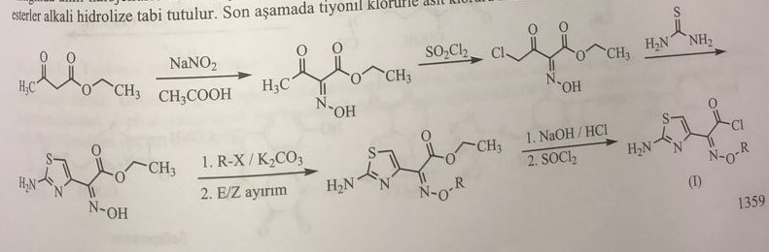
On the other hand, 7-AST first combines the acetoxy group from the third position with the heterocyclic nucleophilic group. Thus, methylcephalosporinic acid with 7-amino-3-nucleophilic group is obtained. The obtained carbonic acid chloride and derivatives of 3-nucleophilic methylcephalosporinic acid are introduced into the reaction in the medium of sodium bicarbonate and acylated the amino group in the seventh position.
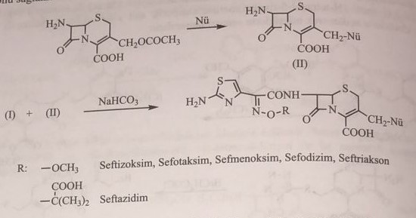
In ceftizoxime, the derivative should be obtained from the third position. For this, it is first necessary to obtain 7-aminocephem-2-carboxylic acid. They use p-nitrobenzyl ester of 3-hydroxy-7-(2-thienilacetamido)-3-cephem-4-carboxylic acid, which was previously used in the synthesis of cefachlor. First, this compound is restored with sodium borohydride to obtain 2,3-dihydro-3-hydroxy-7-(2-thienylacetamido)-3-cepham-2-carboxylic acid 4-nitrobenzyl ether. The formed double alcohol group is acetylated and again forms a double bond between the second and third states of triethylamine and acetic acid.
In ceftizoxime, the derivative should be obtained from the third position. For this, it is first necessary to obtain 7-aminocephem-2-carboxylic acid. They use p-nitrobenzyl ester of 3-hydroxy-7-(2-thienilacetamido)-3-cephem-4-carboxylic acid, which was previously used in the synthesis of cefachlor. First, this compound is restored with sodium borohydride to obtain 2,3-dihydro-3-hydroxy-7-(2-thienylacetamido)-3-cepham-2-carboxylic acid 4-nitrobenzyl ether. The formed double alcohol group is acetylated and again forms a double bond between the second and third states of triethylamine and acetic acid.
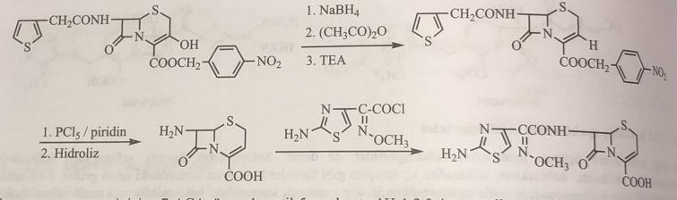
For the synthesis of cefoperazone, 7-AST is first introduced into the reaction with 1-methyl-5-mercapto-1H-1,2,3,4-tetrazole and attached to the third position. Then the amino group in the seventh position is acylated with the grain salt of 4-hydroxyphenylglycine. The synthesis is completed by the reaction of 2,3-dioxo-4-ethyl-1-piperazine with carbonic acid chloride, as in the case of acylureidopenicillins, which form a grain salt.
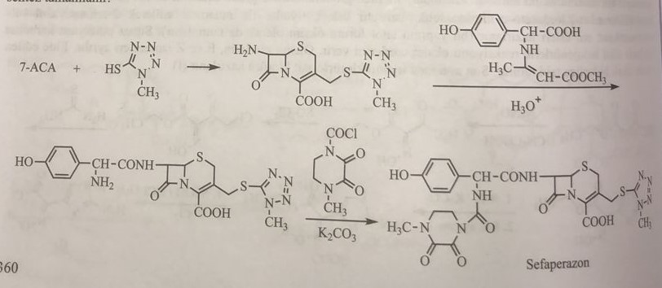
Old oral cephalosporins
These compounds use 7-ADST and 7-amino-3-chlorcephem-2-carboxylic acid as starting material. As a result of acylation of 7-ADST with phenylglycine, cephalexin is obtained, cephalexin is obtained by acylation of α-(1,4-cyclohexadienyl)-α-aminoacetic acid, cefadroxil is acylation with 4-hydroxyphenylglycine. This acylation is protected by the formation of an azomethine structure with ethylacetoacetate in the amino group of α-radical-α-aminoacetate. Then the acylation of 7-ADST in ethyl chloride and triethylamine is carried out.

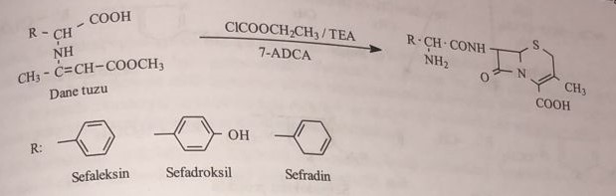
Cefachlor is obtained by the reaction of 7-amino-3-chloro-3-cephem-4-carboxylic acid with phenylglycine. It is obtained using the 4-nitrobenzyl ester of 7-(2-thienilacetamido)cephalosporanic acid, a derivative of 7-amino-3-chlorcephem. For this, the compound is subjected to interaction with potassium xanthogenate to obtain the ether of ethoxydithiocarboxylic acid in the third state. During the reductive pyrolysis of this group, a methylene group is formed in the third position. Oxidation of this double bond produces a 3-hydroxy product, which is chlorinated by thionyl chloride. By splitting the side chain in the seventh position with amidase, p-nitrobenzyl ether 7-AST is obtained. After acylation of this compound with phenylglycine, cefaclor is obtained by cleavage of p-nitrobenzyl ether with trifluoroacetic acid.
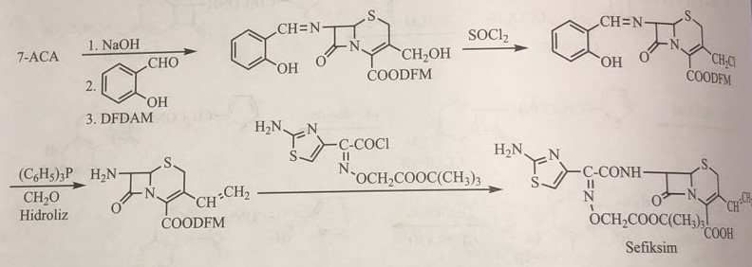
In the synthesis of ceftibuten, ethyl-4-chloroacetoacetate and 3-oxopropionic acid are reacted under Claisen condensation conditions. Then (Z)-2-(2-aminothiazol-4-yl)-4-carboxy-2-butenoyl chloride was obtained with thiosidic acid, and cefibuten was obtained by reacting with 7-aminocephem-2-carboxylic acid.
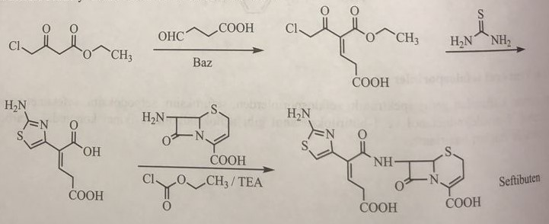
Oxocefem group cephalosporins
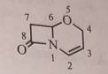
In cephalosporins, as in 6-methoxypenicillins, the addition of a methoxy group to the seventh position makes the molecule resistant to the β-lactamase enzyme. Cefoxitin, cefotetan are representatives of this group of cephalosporins, and are compounds effective against anaerobic bacteria of a wide spectrum. Oxocefem structure-retaining latomoxef and flomoxef sterically protect the β-lactam structure against β-lactamase potassium xanthogenate with the methoxy group in the equatorial α position and the acylamino group in the axial β position in the seventh position.
Latamoxef: (Moxalactam)
In the synthesis of lactomosef, oxosefem is first obtained from 6-APT. For this, thiazole ring is opened by chlorine oxidation and ether is formed with propargyl alcohol. Then 7-amino-8-oxo-3-(1-methyl-tetrazol-5-yl)thiomethyl-5-oxo-1-azabicyclo[4.2.0] octane-2-carboxylic acid diphenylmethyl ester is obtained. Methanol is added to the seventh position with the 4-hydroxy group of the Schiff base prepared in the presence of 3,5-di-tertbutyl-4-hydroxybenzaldehyde from 3,5-di-tertbutyl-4-hydroxybenzylidene. The benzylidene group is removed with the Girard-T reagent, and the free amino group in the seventh position is acylated with 2-phenyl-acetyl chloride for latamoxef and 2-((difluoromethyl)thio)acetic acid for flomoxef to obtain latamoxef.
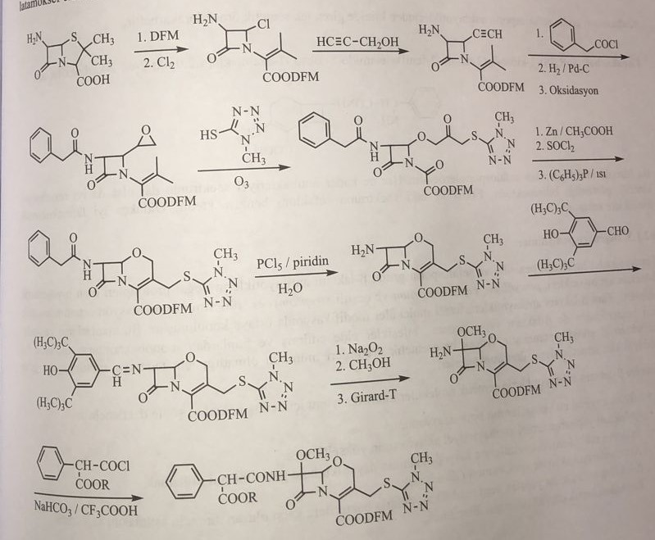
The half-life of latamoxef is 2-6 hours, and it is 45% bound to proteins. It belongs to the group of anaerobic cephalosporins. However, it prevents blood clotting and causes alcohol intolerance.
Flomoxef has the same biological and pharmaceutical properties as latamoxef. The synthesis looks like this:
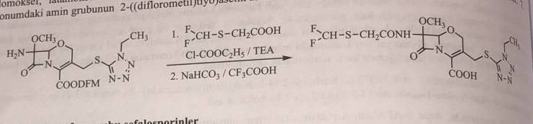
Cephalosporin groups of carbazephems
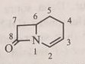
Loracarbef is the only representative of the carbazefem antibiotic group that has entered clinical practice.
Loracarbef: (6R,7S)-3-chloro-7-(2-amino-2-phenyl)acetamido-8-oxo-1-azabicyclo[4.2.0]oct-2-ene-2-carboxylic acid
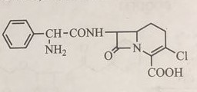
This compound is an orally administered cephalosporin. Although the spectrum of antibacterial action is narrow, it has high resorptive kinetics. Its effect and spectrum of action are similar to tsefaklor. It has very good pharmacokinetic properties.
Monobactam
Sulfazezin, SQ-26445 and SQ-26180, are derivatives of monobactam, isolated in 1980 by Takeda and Squibb. In them, sulfonic acid is attached to the first position of the 1-azocyclobutane ring. Sulfasin was obtained from the culture of Pseudomonas masacido and P. acidophila and entered clinical practice. SQ-26445 was isolated from glycobacteria, and SQ-26180 was isolated from a culture of Chromobacterium violaceum. The basic structure of these compounds is a monocyclic β-lactam. That is why it is called monobactam. These natural compounds were chemically modified, and aztreonam was introduced into medical practice. Monobactams have a sulfonic group in the first position and a methoxy group next to an amino group in the third position. This basic structure leads to an increase in the antibacterial spectrum.
As in penicillins and cephalosporins, the amino group in the third position is acylated by various acids. Derivatives with a wider spectrum of activity were obtained by acylation with 3-aminomonobactam acid or α-(3-amino-4-thiazolyl)-α-alkoxyiminoacetic acid. Thus, aztreonam, tigemonam and carumonam were included in the experiment.
Tigemonam is the most stable compound in relation to β-lactamase. It mainly affects gram(-) bacteria, and the MIC value is within 0.1-1.6. This group is not used against Gram(+) infections.
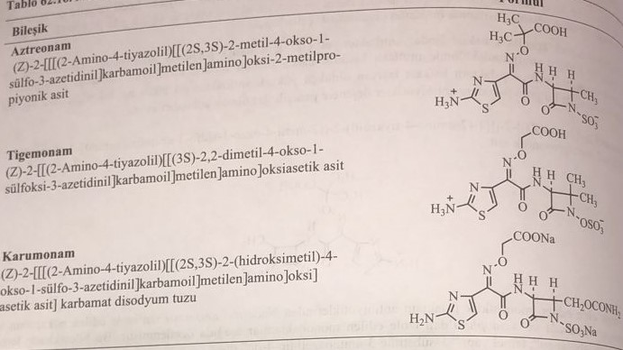
In the synthesis of aztreonam, the benzyl hydroxamate of tert-butyloxycarbonyl-L-threonine is first prepared, and the azetidine ring is obtained with triphenylphosphine and diethoxycarbonyldiimide. Then 1-hydroxy-2-methyl-3-tert-butoxycarbonylamino-azetidin-4-one is obtained. The resulting compound is reduced to 3-amino-4-methylmonobactamic acid. Aztreonam is obtained by acylation with (Z)-2-amino-α[[2(diphenylmethoxy)-1,1-dimethyl-2-oxo-ethoxy]imino]-4-thiazolyl acetic acid.
